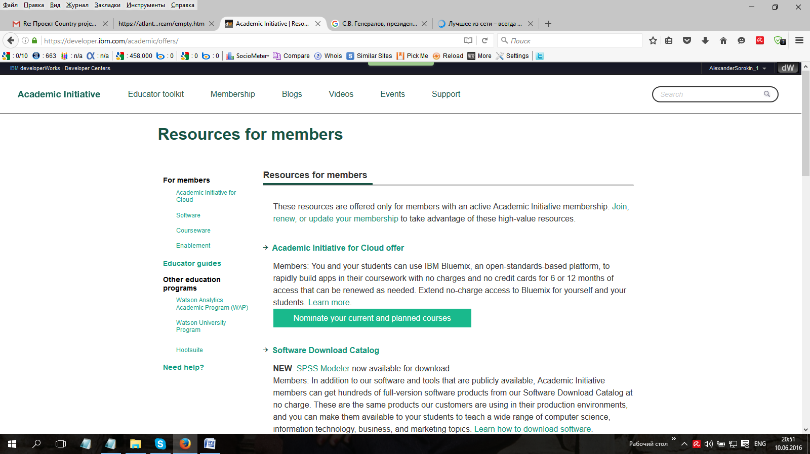

<https://developer.ibm.com/academic/offers/>

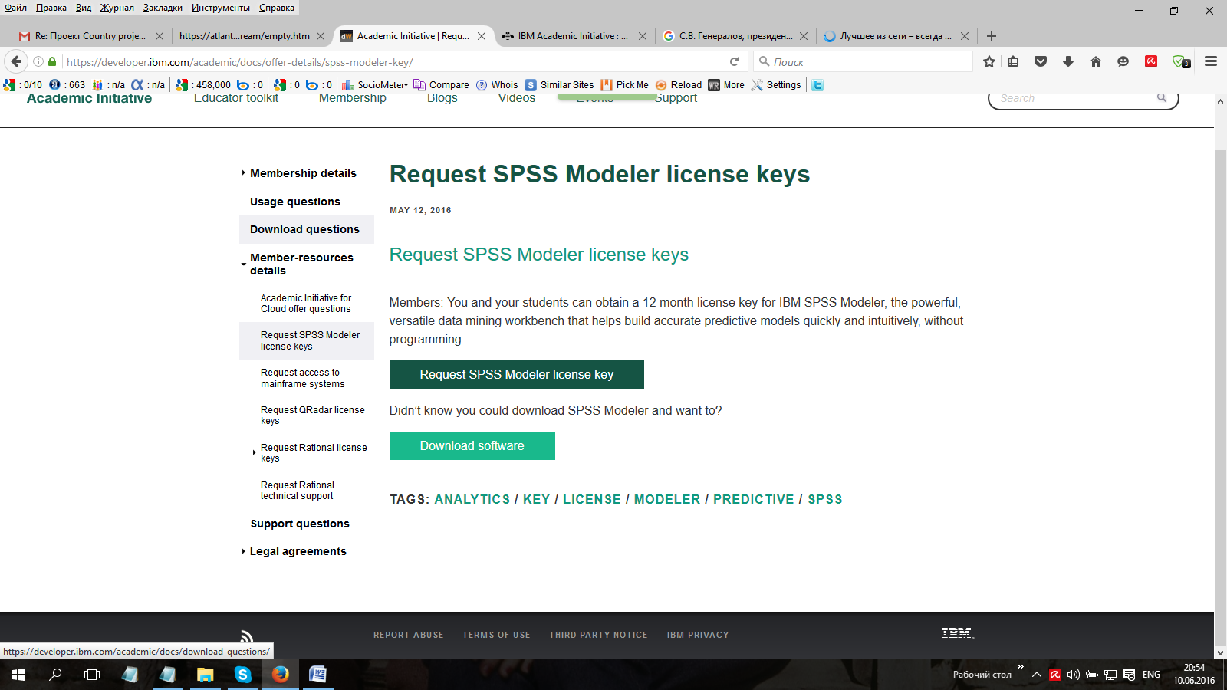

<https://www-304.ibm.com/ibm/university/academic/member/page/spss_key>

